Sharing a File in One Drive with a Class

- Open the OneDrive folder on your computer.
- Right-click the file you want to share and select “Share” from the menu that appears.
- A small sharing window will appear. Rather than entering individual names, we’re going to set it so that anyone with the link can access the file.
- Click the “People You Specify Can Edit” box in the small sharing window.
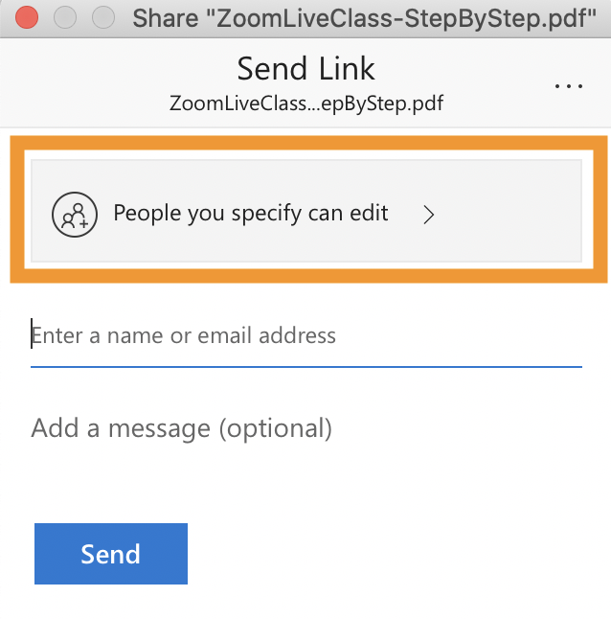
- In the window that appears, click on “People in Johns Hopkins with the link” and deselect “Allow Editing.”
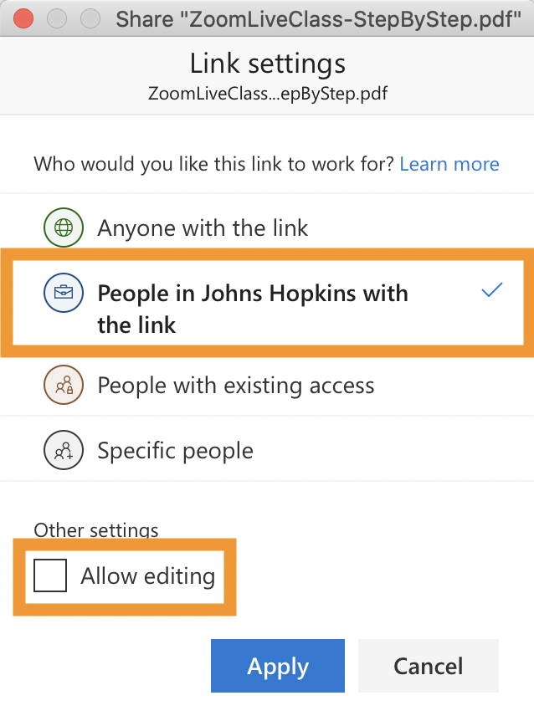
- Click “Apply”
- Back in the sharing window, click “Copy Link.”
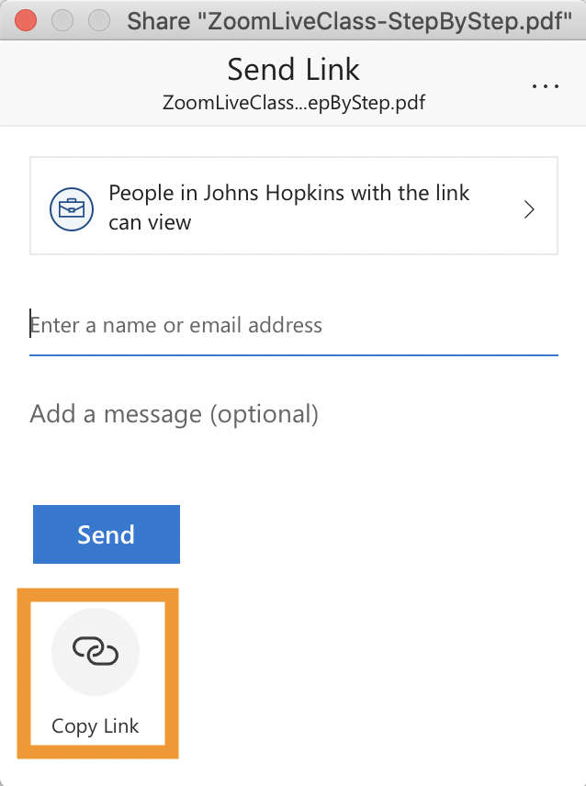
- In the copy link window, click the “Copy” button.
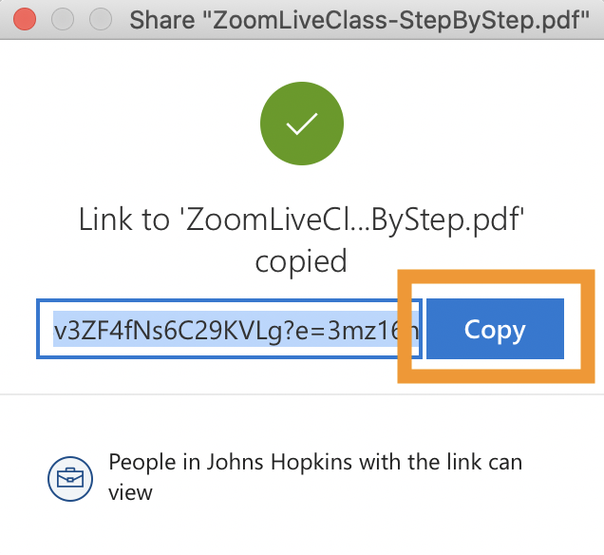
- Create a new link in the Online Library in your CoursePlus site with this link.

