AI-Resistant Assessment Design Worksheet

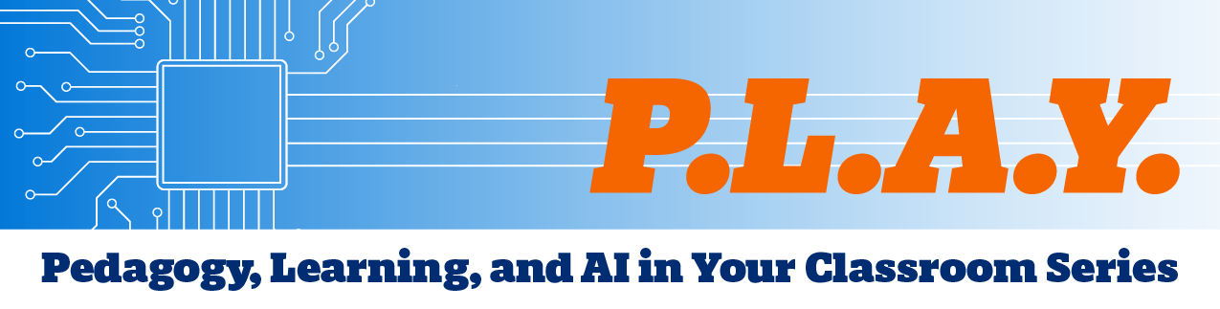
Use this worksheet to design generative artificial intelligence (AI)-resistant assessments that align with your learning objectives and provide meaningful evidence of student learning. The activities in this worksheet are intended to guide you through the process of 1) evaluating an existing assessment, 2) identifying AI vulnerabilities, and 3) exploring redesign strategies.

Activity 1: Chose an Assessment
Course | Assessment Title | Assessment Type  (Exam, paper, presentation, etc.)

Briefly describe the assessment

Learning Objective(s): What should students be able to demonstrate or accomplish during the assessment?

Activity 2: AI Vulnerability Scan
Imagine a student has unrestricted access to generative AI. Which parts of this assessment could AI complete successfully?
Part | Yes/No
Generate ideas
Summarize readings
Write responses
Produce an essay draft
Complete discussion posts
Create presentation content
Solve problems
Other:
To further test your assessment for AI vulnerabilities, consider uploading it into HopGPT to test what outputs are generated.

Rate the Assessment’s Vulnerability
How vulnerable is your assessment to generative AI?
- Very Vulnerable
- Somewhat Vulnerable
- Minimally Vulnerable

Activity 3: Make the Assessment More AI-Resistant
AI often produces polished products, but it cannot independently demonstrate a student's reasoning, decision-making, or participation in course-specific experiences. Select 1-2 strategies that could strengthen your assessment.
*See the "AI-Resistant Strategies Reference Guide" section at the end of this worksheet for strategy descriptions and examples.
Strategy | Yes/No
Strategy 1: Require students to defend their thinking.
Students must explain, justify, or defend their decisions, reasoning, or conclusions.
Strategy 2: Assess the process.
Focus on how students arrived at their final work.
Strategy 3: Create opportunities for real-time interaction.
Require students to think, respond, and demonstrate understanding in real time, with limited opportunities to outsource work to AI tools.
Strategy 4: Use authentic professional tasks.
Ask students to perform work like what professionals in the field do.
Strategy 5: Apply learning to unique contexts.
Require students to work within a context that is specific, authentic, or evolving.

Activity 4: Reflection
How will you incorporate one or more of these strategies into your assessment? If it is an existing assessment, what changes will need to be made?

AI-Resistant Strategies Reference Guide

Strategy 1: Require students to defend their thinking
Students must explain, justify, or defend their decisions, reasoning, or conclusions.

Examples
- Whiteboard defense
- Oral exam
- Case study defense
- Proof discussion
- Design defense

Possible approaches
- Explain reasoning in an oral discussion
- Defend recommendations or conclusions
- Justify methodological choices
- Respond to instructor questions
- Explain why alternative approaches were rejected

Public Health Application
Epidemiology students present an outbreak investigation plan and defend their choice of study design, case definition, and data collection methods.

Strategy 2: Assess the process
Focus on how students arrived at their final work.

Examples
- Experimental design defense
- Field research presentation
- Peer code review

Possible approaches
- Proposal or project plan
- Research log or journal
- Drafts and revisions
- Reflection on key decisions
- Documentation of troubleshooting and problem-solving
- Explanation of how feedback was incorporated

Public Health Example
International Health students maintain a project journal (written or recorded) documenting how they adapted a program design to cultural, economic, or political constraints identified during research.

Strategy 3: Create opportunities for real-time interaction
Require students to think, respond, and demonstrate understanding in real time, with limited opportunities to outsource work to AI tools.

Examples
- Socratic seminar
- Structured academic debate
- Mock trial
- Oral defense
- Handwritten/Blue Book exam

Possible approaches
- Live presentation with Q&A
- Small-group discussion
- Debate or structured argument
- Oral examination
- Follow-up questioning after submission
- In-class demonstration

Public Health Example
Health Policy students participate in a policy debate on a proposed public health intervention and respond to questions from peers role-playing as policymakers.

Strategy 4: Use authentic professional tasks
Ask students to perform work similar to what professionals in the field actually do.

Examples
- Patient consultation
- Client consultation
- Studio critique
- Policy simulation

Possible approaches
- Consultation or advising scenario
- Professional presentation
- Stakeholder recommendation
- Client-facing deliverable
- Performance-based assessment
- Simulation of professional or workplace responsibilities

Public Health Example
Environmental Health students develop and present a policy brief addressing a local environmental exposure concern for a county health department in a role-playing exercise.

Strategy 5: Apply learning to unique contexts
Require students to work within a context that is specific, authentic, or evolving.

Examples
- Historical role-playing
- Field research presentation
- Policy simulation
- Case study defense

Possible approaches
- Local or institutional issue
- Current event
- Community-based project
- Student-collected data
- Course-specific case study
- Role-playing or scenario-based activity

Public Health Example
Molecular Microbiology and Immunology students analyze an emerging pathogen scenario and recommend surveillance, prevention, or laboratory investigation strategies based on known microbiological principles.

