Activities: HopGPT as a Concierge Service to Promote and Support Learners’ Agency

ACTIVITY 1: Login to HopGPT
Start here and select “Launch HopGPT”. You will navigate to the tool and be prompted to sign in with your JHED ID.
If you do not have access to HopGPT, please visit any large language model if you would like to actively participate in some of this session’s activities. Some alternative options include:
- Copilot (no sign-in required)
- ChatGPT (no sign-in required)
- Claude (requires sign-in)

ACTIVITY 2: Use HopGPT to Collaborate in Brainstorming
We will interact with HopGPT (or other AI tool) to help us brainstorm.

- Select the “New Chat” icon in the vertical navigation menu of the sidebar in HopGPT.
- [Optional] Select a different LLM (Large language Model).
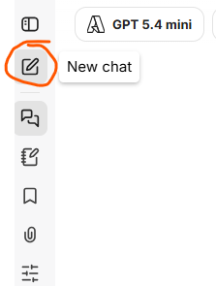
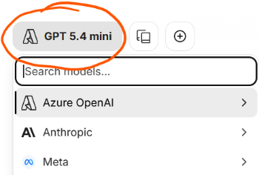

- Copy and paste the following prompt into the chat. Edit, if desired. Then send the message (i.e., submit or select “enter” on your keyboard).
Create a table that lists five practices or strategies that align with the theory of self-directed learning and are appropriate for a graduate student. Make them also align with Universal Design for learning and Knowles' theory of the adult learner. Use no more than 500 words.
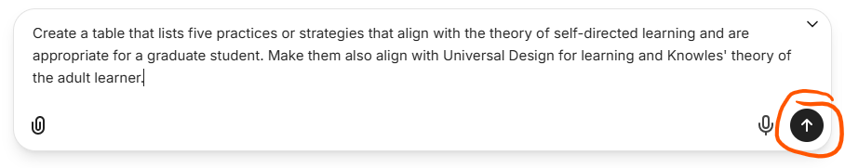
- Review the output and consider if these results are helpful to you. If not, challenge the AI with a simple statement such as:
Can you be more original in your thinking?
- Share one strategy in our session’s chat as a response to the quick poll. Either brainstorm a new strategy or copy and paste from the AI output.

ACTIVITY 3: Reflect on Learning Styles, Values, and Strengths
For today’s activity, we will be using a profile for a mythical student. Review the results, below, for this student who used some online tools to find their learning style and three other tools to learn about their values and strengths. How might these characteristics help our student identify Self-Directed Learning (SDL) strategies that work best for them? Consider the strategies we identified in the previous activity. Would they work well for this learner?

Sample Results for Today’s Use

The Kolb Experiential Learning Profile (KELP) tool determined this student’s dominant learning style is the Deciding Style. This style lies at the intersection of thinking and doing; it is a convergent style where foundations and reflections have turned into theories, and plans are being made for what’s next. (Find more insights into the different styles in The Kolb Experiential Learning Profile (KELP) Guide to Experiential Learning Theory, pp. 12-14.)
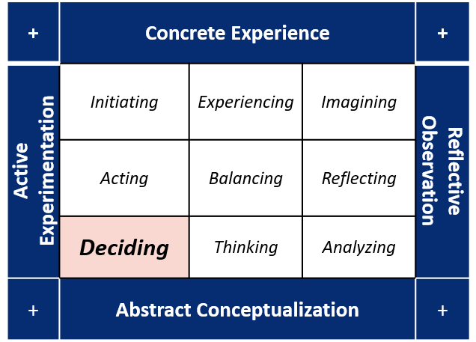

To identify core values and strengths, the student used the Good Project’s Values Sort tool, the Positivity Project’s Character Strengths Survey, and the VIA Character Strengths Survey. (The tools are linked below the table.)
Most Important Values  Values Sort Tool (The Good Project) | Reliable Strengths  Character Strengths Survey (Positivity Project) | Top 5 Strengths  VIA Character Strengths (VIA Institute on Character)
Balance | Perseverance | Honesty
Common Good | Integrity | Fairness
Efficiency | Optimism | Appreciation of Beauty & Excellence
Trust | Humor | Judgement
Helping Others | Self-Control | Perspective

[Optional] Finding Values and Strengths
We can share the following or similar tools with our students to help them have insights into their values and strengths. (You are encouraged to use them, too!)
- Guided Reflection:
  - Values Reflection Toolkit (University of Edinburgh)
  - Signature Character Strengths Survey (VIA Institute on Character)
- Survey-type Tools:
  - Values Exercise (Think to Perform) – no login ( ≈ 10 –15 min)
  - Value Sort Tool (The Good Project) – no login
  - Character Strengths Survey (Positivity Project) – no login ( ≈ 5 –10 min)
  - Strengths Test (High 5 Test) – free but login required
  - VIA Character Strengths Survey (VIA Institute on Character) – free but login required

ACTIVITY 4: Create and Use HopGPT for a Saved Prompt with Three Variables
Note: You can learn more about formatting AI chat prompts in our “Extended Information” document.

- Select the “Prompts” icon in the vertical navigation menu of the sidebar in HopGPT.
- Select the “Create Prompt” (plus sign) icon at the top.
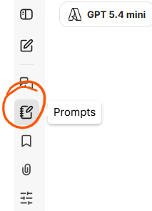
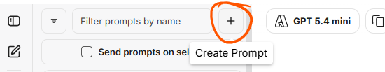
- Give your prompt a name and then, in the “Prompt input” text box, copy and paste the following text. Edit it, if desired, but make sure to keep your variables in the double curly braces.
Create a table that lists {{number}} practices or strategies that align with the theory of self-directed learning and are appropriate for a graduate student. Make them also align with Universal Design for learning and Knowles' theory of the adult learner. These activities should be appropriate for {{choose one: small groups | individuals}} to complete within {{choose duration: 1 hour|1 week|2 hours}}. Use no more than 500 words.
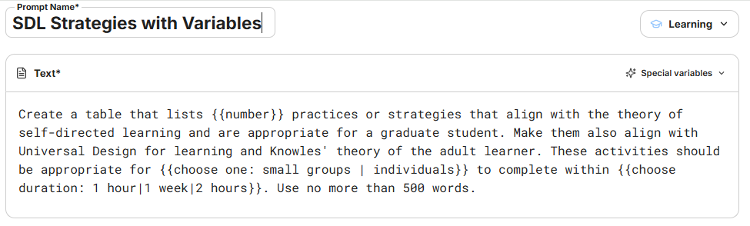
- Scroll down if necessary. Select the words “Create Prompt”, at the bottom right, to save your prompt. It will appear in the prompts menu on the left side of your screen.
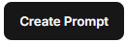
- Hover over your prompt’s name in the menu to see the “three dots” menu. Select the dots to expand the menu and select “Preview”. The preview will be displayed in an overlay.
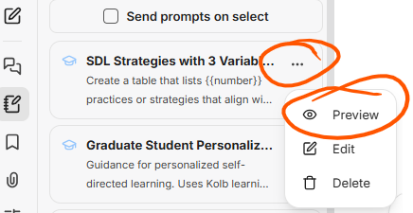
- Select “Use prompt” at the bottom right of the preview’s display.

- In the pop-up, the full prompt will be displayed with its variables. Under it will be two boxes with your variable names. Enter values for your variables and you will see your prompt’s display changed from showing highlighted variable placeholders to bold text using the values you entered. Select “Submit” to see the complete prompt displayed as a chat ready to send.
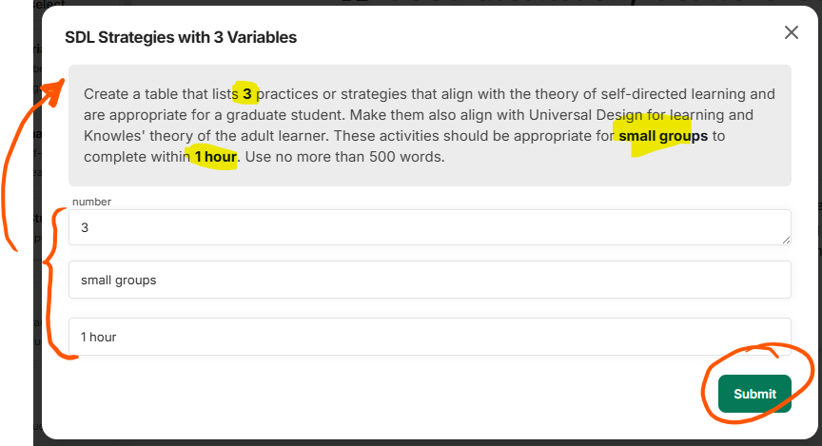
- Send the prompt chat. Review the output it returns.
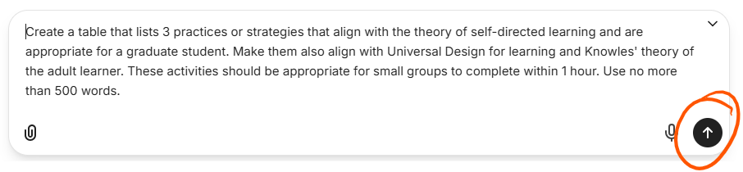
- If you want to use the prompt again with different values in the placeholders, navigate to the list of prompts and just click on the name to use it. (There is no need to use the three dots menu if you’re not in an editing mode.)

ACTIVITY 5: Create and Use HopGPT for a Saved Prompt towards Personalized Learning
- Select the “Prompts” icon in the vertical navigation menu of the sidebar in HopGPT.
- Select the “Create Prompt” (plus sign) icon at the top.
- Give your prompt a name and then, in the “Prompt input” text box, copy and paste the text of one of the following prompts. Edit it, if desired, but make sure to keep your variables in the double curly braces.
Option 1: Personalized SDL
You are a graduate student learning about {{course or topic?}}. Identify {{number of activities?}} active learning strategies that draw upon your learning style, values, and character strengths to help you {{list your goal or objective(s)}}. Your Kolb Experiential Learning Profile style is {{select style: experiencing |imagining |reflecting |analyzing |thinking |deciding |acting |initiating |balancing |unknown}}. These are your values and character strengths: {{list top values and/or character strengths}}. Create a table of the strategies and their alignment to these traits. Describe how each strategy helps you, plus list any required resources. I am only interested in {{specify if you prefer individual or group: group |individual |either group or individual}} activities that can be completed in {{enter time to complete (with hours, days, or weeks)}}.
Option 2: Opportunities for Personal Growth
You are a {{say something about your identity, e.g. "professional working in ..."}} and your top VIA character strengths are {{list top 2 to 5 character strengths}}. Your underutilized strengths are {{list underutilized strengths}}. Please suggest three activities that you could do {{select type: as an individual | with others | either alone or with others}} on a regular basis that would enable you to tap into all of these at once. Use no more than 600 words.
- Scroll down if necessary. Select the words “Create Prompt”, at the bottom right, to save your prompt.
- Select the new prompt’s name from the prompts menu to use it.
- Enter values for Option 1 using a course or topic of your choice, any number of activities, the goal or objective of your choice, and the traits of our mythical student from Activity 3. Also specify if your student wants to work alone or with a group, plus choose a time it should take for them to complete the suggested activities.
For Option 2, enter values that reflect you. For this exercise, you can use the Signature Character Strengths Survey to help you pick sample character strengths.
- Select “Submit” to see the complete prompt displayed as a chat ready to send.
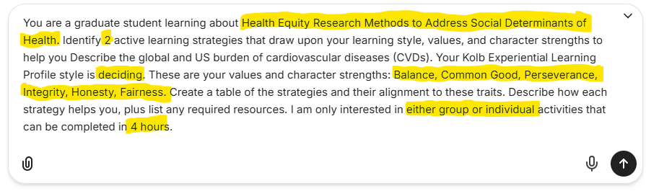
- Send your prompt and review its output.
- Your submitted prompt is now available in your list of chats. Optionally copy the chat’s original prompt text (with no variables) to use in a new prompt, changing the learning style and traits (values or character strengths) to compare and contrast the output.
